Lazarus Sail Mode
White Paper Proof of Concept for an Emergency Solar-Skin Recovery and Low-Thrust Survival Mode
Document Type | Emergency propulsion and survival-mode proof-of-concept white paper
Concept Thesis | Use Prismatic Solar Skin as a survival-energy sail, CPSS as the emergency buffer, and tri-core propulsion in degraded low-thrust mode to preserve maneuver authority after major power loss.
Primary Use | Emergency power continuity, low-thrust drift recovery, attitude control, and slow return-to-port behavior
Status | High-level concept architecture draft
Abstract
Lazarus Sail Mode is an emergency spacecraft operating concept that combines the Prismatic Solar Skin energy surface with CPSS buffering and a degraded tri-core propulsion state. The goal is not to replace the primary drive with a miraculous solar sail. The goal is to preserve survivability when the ship is power-starved, damaged, or reactor-limited. In this mode, the outer energy skin harvests direct solar input, recovers part of the thermal burden, and feeds a CPSS emergency reserve layer. That reserve stabilizes critical loads and supports a reduced tri-core operating state capable of low-thrust maneuvering, drift correction, station-keeping, and emergency return. The concept is therefore best understood as a survival-energy sail: a hull-scale utility mode that keeps the ship alive and controllable when full propulsion authority is gone.
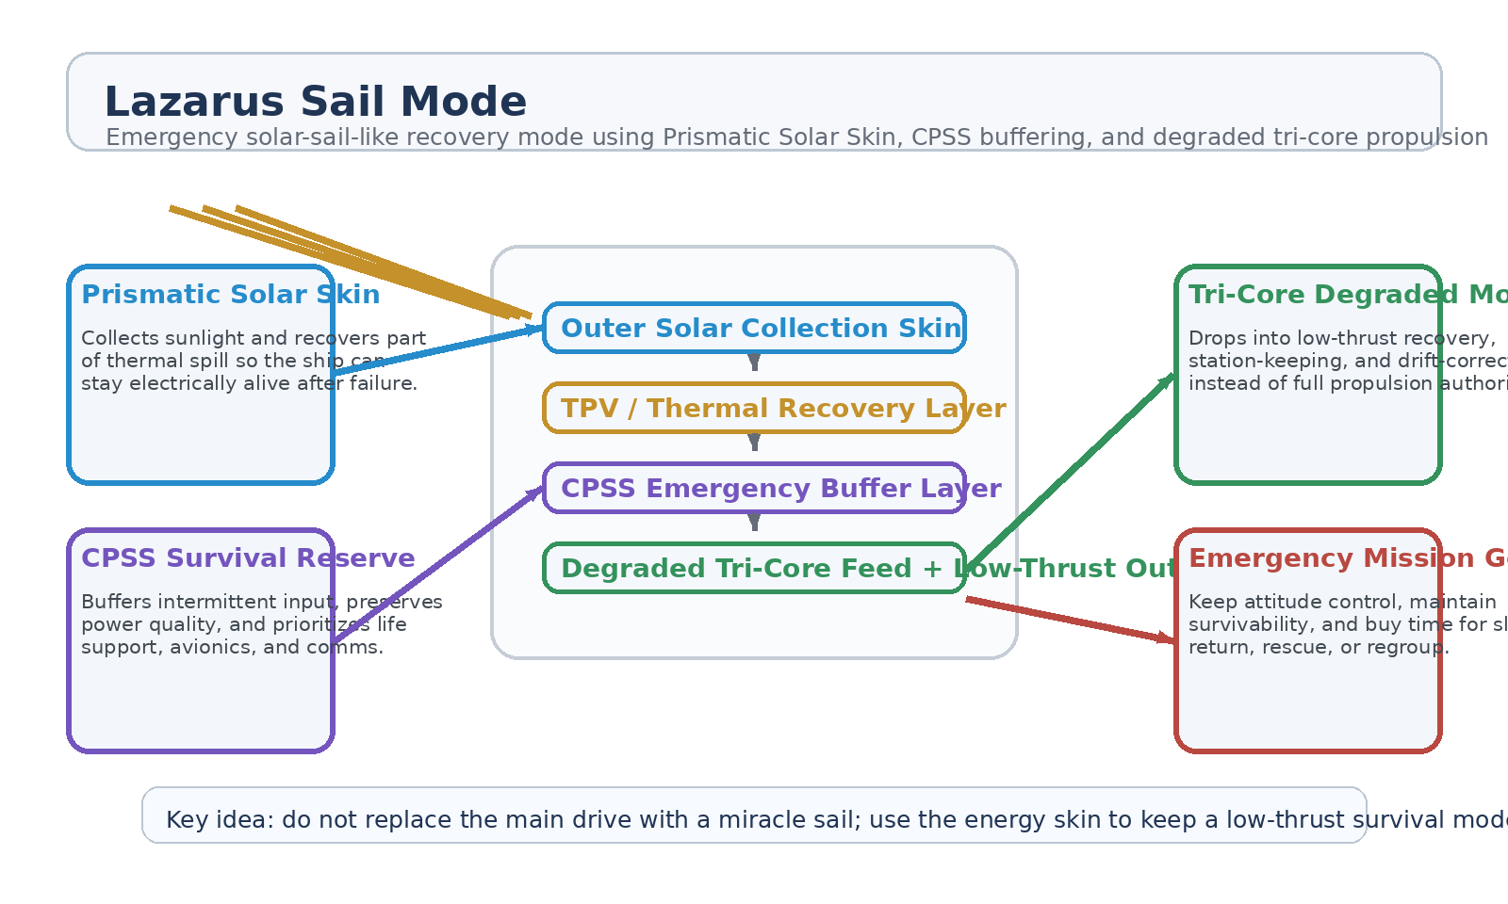
Figure 1. Lazarus Sail Mode with Prismatic Solar Skin, TPV recovery, CPSS emergency reserve, and degraded tri-core low-thrust output.
1. Concept Thesis
The core idea is to turn the outer energy skin into a true emergency operating layer. Under normal conditions, the ship still relies on its main tri-core propulsion architecture. Under degraded conditions, however, the skin can be treated as a large-area survival intake surface that collects solar energy, recovers heat, and keeps a reduced-power propulsion and control state alive. This produces a mode that behaves somewhat like an upgraded solar sail in mission effect, while remaining tied to a more coherent engineering story: energy harvest, buffering, and low-thrust propellant-based maneuvering.
In plain terms, the ship does not become fast. It becomes hard to kill.
2. Why the Source Documents Fit Together
The tri-core propulsion architecture already separates steady power, propellant logistics, buffering, and actual thrust generation into distinct roles. That means the propulsion side can gracefully step down into a lower-energy operating mode rather than collapsing into an all-or-nothing system.
The Prismatic Solar Skin concept already defines the hull as a layered energy organ with direct collection, thermal recovery, CPSS conditioning, and prismatic routing. That makes it a natural emergency power source when the main stack is damaged or constrained.
Together, the two concepts support a realistic emergency doctrine: keep power alive through the skin, keep quality stable through CPSS, and spend that reserve on only the minimum propulsion and control needed to survive.
3. System Architecture
Layer | Subsystem | Primary Function | Emergency Role
L1 | Prismatic Solar Skin | Harvest direct solar input across the hull and capture useful thermal spill. | Emergency energy intake
L2 | TPV / Thermal Recovery | Convert part of the infrared and heat load into usable electrical support. | Extends survival yield
L3 | CPSS Emergency Buffer | Smooth intermittent input, preserve reserve power, and prioritize critical loads. | Survival reserve
L4 | Degraded Tri-Core State | Use remaining power and propellant for very low-thrust propulsion and control. | Slow maneuver authority
L5 | Mission Recovery Logic | Allocate power to life support, avionics, attitude control, comms, and return behavior. | Stay alive long enough to recover

3.1 Solar Skin as the Emergency Intake Surface
In this mode the hull skin becomes the survival intake layer. Its role is not to replace the reactor during normal operations, but to make use of any available sunlight and thermal burden when the ship most needs extra survivability margin. This means the skin contributes to electrical continuity even if the main plant is offline, throttled, or protecting itself.
3.2 CPSS as the Lifeboat Reserve
CPSS is the right place to concentrate emergency discipline. It can buffer intermittent energy, absorb mismatch, store scarce recovered power, and then release that power where it matters most. In a recovery scenario that means life support, navigation, attitude control, communications, and minimum propulsion take priority over comfort or peak-performance loads.
3.3 Degraded Tri-Core Propulsion
The tri-core stack remains physically grounded when interpreted in low-thrust form. Reactors and buffers supply power, Genesis-style systems maintain propellant logistics, and the thruster still operates by accelerating propellant or using another real momentum-exchange path. Lazarus Sail Mode does not break that rule. It simply assumes the ship has fallen back to a low-authority operating state where survivability and control matter more than speed.
4. Operational Modes
Mode | Power Behavior | Propulsion Behavior | Outcome
Survival Hold | Solar skin + CPSS maintain core loads. | Minimal thruster activity for attitude trim only. | Crew and systems remain alive
Drift Recovery | CPSS meters recovered energy into control bus. | Low-thrust corrections reduce uncontrolled drift. | Ship regains directional discipline
Return-to-Port | Skin and reserve feed long-duration reduced loads. | Continuous very low-thrust cruise or station-keeping. | Slow recovery trajectory
Beacon Preservation | Power is rationed toward comms, nav, and life support. | Propulsion used only when necessary for safety. | Maximum survival window

5. Why This Is Better Than Saying 'Solar Sail'
• The concept does not rely on radiation pressure alone to explain recovery behavior.
• The outer skin still performs a real collection job instead of becoming pure metaphor.
• CPSS gives the system a disciplined reserve instead of a fragile direct-feed dependency.
• The propulsion side remains tied to real low-thrust momentum exchange instead of reactionless motion.
• The result feels sail-like in mission behavior while staying closer to a coherent systems story.
6. Mission Roles
• Emergency reactor-loss or reactor-throttle survival mode.
• Extended low-thrust drift recovery after battle damage or major system fault.
• Long-duration attitude and station-keeping when conventional drive authority is gone.
• Slow return-to-port or rescue-vector maintenance.
• Lifeboat-like operating state for large ships that still retain hull surface area and minimum propellant flow.
7. Boundaries and Realism
Lazarus Sail Mode is strongest as a survivability doctrine, not as a replacement for the main propulsion architecture. The ship will not accelerate like a normal combat vessel in this mode. The energy skin will not make the vehicle magically self-sufficient in every environment. The concept works best when there is still sunlight available, when the ship can still route some propellant to a low-thrust stage, and when emergency reserves are being carefully rationed.
• Most credible as an emergency and degraded-mode operating state.
• Not a substitute for the full tri-core propulsion system under normal mission demand.
• Still constrained by thermal limits, propellant availability, and the low power density of solar recovery.
• Best suited to preserving survival time, attitude control, and slow maneuver capability rather than speed.
8. Proof-of-Concept Build Path
Phase | Goal | Bench / Program Activity | Success Signal
P1 | Skin baseline | Validate hybrid collection, thermal recovery, and CPSS buffering on a representative layered surface. | Stable emergency power path
P2 | Critical-load prioritization | Demonstrate reserve allocation to a reduced set of life-support and avionics loads. | Graceful low-power survival state
P3 | Low-thrust coupling | Feed conditioned reserve power into a small electric/plasma thruster surrogate. | Sustained reduced thrust
P4 | Drift recovery scenario | Model or bench-test attitude correction and minimal maneuvering under survival loads. | Measured control authority
P5 | Endurance review | Compare reactor-out baseline against skin-assisted survival mode over an extended run. | Longer survivable operating window

9. Conclusion
Lazarus Sail Mode is most coherent when understood as a survival-energy doctrine rather than a heroic propulsion claim. The outer skin keeps harvesting. The inner thermal layer keeps recovering. CPSS keeps the output usable. And the tri-core system falls back to the smallest real propulsion state that still matters.
As a white paper PoC, the concept is a disciplined answer to a hard question: when the main drive is wounded, what keeps the ship alive long enough to come home?
Working one-line doctrine: Do not ask the skin to replace the main drive; ask it to keep a low-thrust survival mode alive long enough to maneuver, stabilize, and return.

